

This voter guide provides a list of all eligible executive tickets participating in the 2025 ASUU General Election. The ASUU General Election is conducted to elect ASUU student leaders for the 2025-2026 academic year. Elected positions include Executive Tickets, Attorney General, Assembly members for each college, and Senators for each college. Each executive ticket consists of the following positions: ASUU President, ASUU Vice President of University Relations, and ASUU Vice President of Student Relations. Winners are selected based on the total number of votes.

Voters will select one option for Executive Tickets, Attorney General, and College Senators, while their options for College Assembly members will vary depending on the size of their respective college. The ASUU General Election will take place from February 18th through February 28th, 2025.

Assembly and Senate colleges are listed in alphabetical order but candidates are listed in the order of their filing application. Candidate photos (aside from executive tickets) are the photos candidates submitted at filing. If a photo is missing, it means the candidate either did not submit a photo or the photo they submitted could not be used. Additionally, platform statements are included only for candidates who provided a statement.
Elections-related questions should be directed to the ASUU Elections Board
Elections Director – Aynaelyssya Thomas (athomas@asuu.utah.edu)
Elections Associate Director – Aaliyah Franco (afranco@asuu.utah.edu)
Elections Associate Director – Kei Man Wong (kwong@asuu.utah.edu)
Please visit the ASUU Website for more information regarding elections: https://www.asuu.utah.edu/elections/

Table of Contents

Page Position/ College
- Overview of Voter Guide
- Table of Contents
- Executive Tickets Candidates
Candidates are listed in alphabetical order
- Attorney General
Candidates are listed in alphabetical order by last name
- Assembly Candidates
Candidates are listed in colleges Alphabetical order then in order of candidate filing
- Senate Candidates
Candidates are listed in colleges Alphabetical order then in order of candidate filing.
- QR Code to Vote

Executive Ticket Candidates
The ABC Ticket
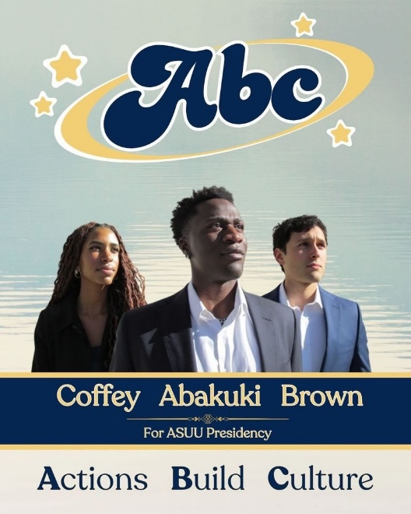
Platform Statement: We want to foster community where every student is heard, valued, and included. Through respectful discourse and thoughtful action, we will lead with kindness and deliver exceptional results for all students- regardless of background, beliefs or affiliations. We strive to shape a culture of unity, respect and opportunity for the University of Utah students and work effectively with partners across campus and in local communities.

Together, our actions will build tomorrow’s culture.


Rose Ticket
Platform Statement: “Transform your student experience at the University of Utah with the Rose Ticket, making every moment truly unforgettable. As leaders who listen, your voice will shape the changes you want to see on campus. The college experience should be exciting, so we are ready to blaze new trails by creating more vibrant events and encouraging a campus culture that’s bold, exciting, and memorable. From enhancing traditions to introducing innovative opportunities, we’re here to make your student experience more meaningful and full of life.
We are committed to protecting what matters most: your mental and physical wellbeing. By advocating for resources that promote health, safety, and balance, we aim to ensure every student thrives. Ultimately, we’re here to foster connections. Whether it’s guiding you to find your place, your people, or your purpose, we’re dedicated to ensure everyone feels they belong. With your voice leading the way, together we’ll Rise Up with Rose to create a stronger, more connected, and brighter future for our campus community”

Singh Ticket

Platform Statement:
To the Student Body @ The University of Utah,
Most of us are quick to notice things that cause us dissatisfaction. Some of us are even brave enough to call them out. The Singh Ticket is no different. During our time on-campus, we have found ample things to worry about. Parking lots are ripped out despite perpetual parking shortages, sprinklers seem intent on watering sidewalks, shuttles serve as a slightly slower alternative to walking, state legislatures relish abolishing certain study-programs, clubs never have enough funding, students suffer at the hands of criminals . . . the list continues ad infinitum.
Talking about these problems is good. It brings awareness to these issues. Bring enough of it to bear and someone higher-up may even lend a sympathetic ear to the cause. That, of course, is all one can hope to accomplish by employing only such methods. Good but not good enough. Far better would be to take a step further – to enact tangible solutions that fix the problems at hand.
The Singh Ticket aims to do exactly that. Students prefer their parking lots intact, so let us give them a vote in the U’s physical development planning process. The U’s Impact 2030 plan aims to “reduce reliance upon single-occupancy vehicles.” With or without a car, we still need to reach our beloved mountain destinations. Establishing a year-round bus service to-and-fro the resorts would relieve those left with walking as their only option. State legislatures seek to abolish “low ROI academic programs.” Let us convince them that ROI is not the only reason one partakes in education. Clubs must spend out-of-pocket before winning ASUU funding. Why not give a proven few of them permission to fund events directly out of ASUU resources? They can even avoid paying sales tax that way. UUPD data indicate specific on-campus areas as hotspots for crimes like sexual batteries and harassment. Why not assemble an ad-hoc committee to investigate such affairs and recommend improvements to existing safety structures? These are but a few items on our agenda.
Perhaps all this seems too good to be true. One learns, after all, to take the promises of politicians with a grain of salt. Not only that, with advocacy being its primary tool, ASUU hardly has a mandate to directly enact these changes even if it wanted to. Further, is it not just student government? A safe-space for students to LARP as government officials – perhaps adorn their resumés while they are at it?
Nearly three years ago, a bitter and ignorant Sunny would have agreed. Now, nothing else seems further from the truth. ASUU is responsible for, among other things, securing a $42.5 million bond from the Utah legislature to fund the Student Life Centre – a facility most of us take for-granted. ASUU also secured a $3 million donation from the Eccles foundation to fund Campus Recreation Services – taking burden off student-fees for years to come. It established the “ASUU Marriott Library Tutoring Centre,” which is proudly known today as the “Learning Centre.” It won $13.5 million in direct funding from the Utah legislature to renovate the School of Nursing.
Any organization lucky enough to exist for a long time may end up with a few highlights in its past. To the more skeptical, achievements in recent history are what really count. Thankfully, ASUU does not lack them either. Anyone navigating to the ASUU website will see a list of discounts at local businesses available to students through their U card. These were, by and large, organized by the very current year’s presidency and their cabinet. Current ASUU leaders have already kick-started a plan to give students votes in the development of a new “Landscape Master Plan” to solve the sprinkler problem aforementioned. We can go on for pages, but platform statements can only be so long.
In light of ASUU’s achievements both past and current, the Singh Ticket’s ambitions seem downright tame – and that much more plausible. We have researched how ASUU secured these victories in the past, and have made plans to replicate those methods. In summary, we know exactly what works when it comes to finding solutions behind our sentiments.
Sincerely,
Sunny Singh, Olivia Saenz, Elle Williams
The Singh Ticket
Presidential Candidates | ASUU 25 – 26

Attorney General Candidates
Jacob Bastian
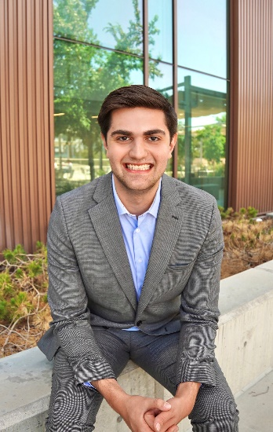
I’m running for Attorney General to bring real accountability, support, and clarity to ASUU. Together, we’ll make student government fair, transparent, and focused on you. No overreach, no confusion—just results. Let’s make ASUU Better with Bastian!

Katie Nelson
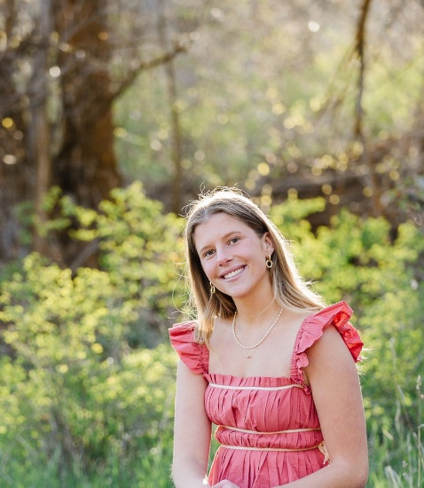
If elected as attorney general I would work to promote uphold the bylaws of Redbook and advocate for students across campus. I would be an honor to receive your vote!

Assembly Candidates
Architecture & Planning
Keila Torres Ayon
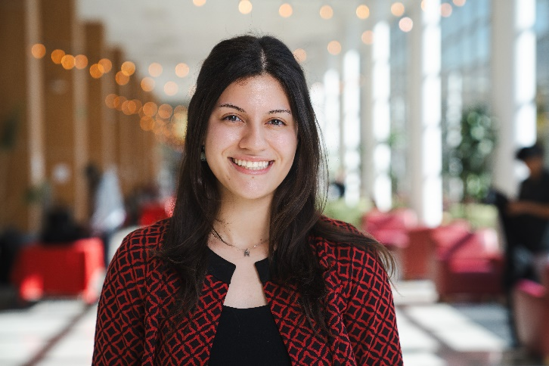

Business
Doom Alminhali
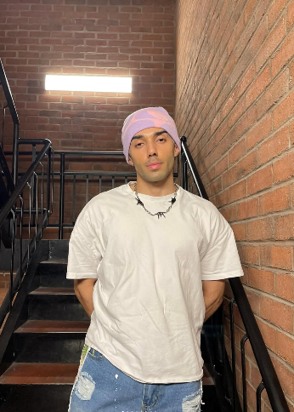

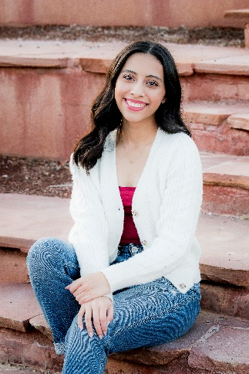
Gaby Renteria
Hi Utes! I want to create a town hall for RSO leaders to provide clarity on how to effectively run their club. I also I aim to table, collaborate with RSOs, and engage with students. Roar into Action, vote Gaby!

Hanson Gu
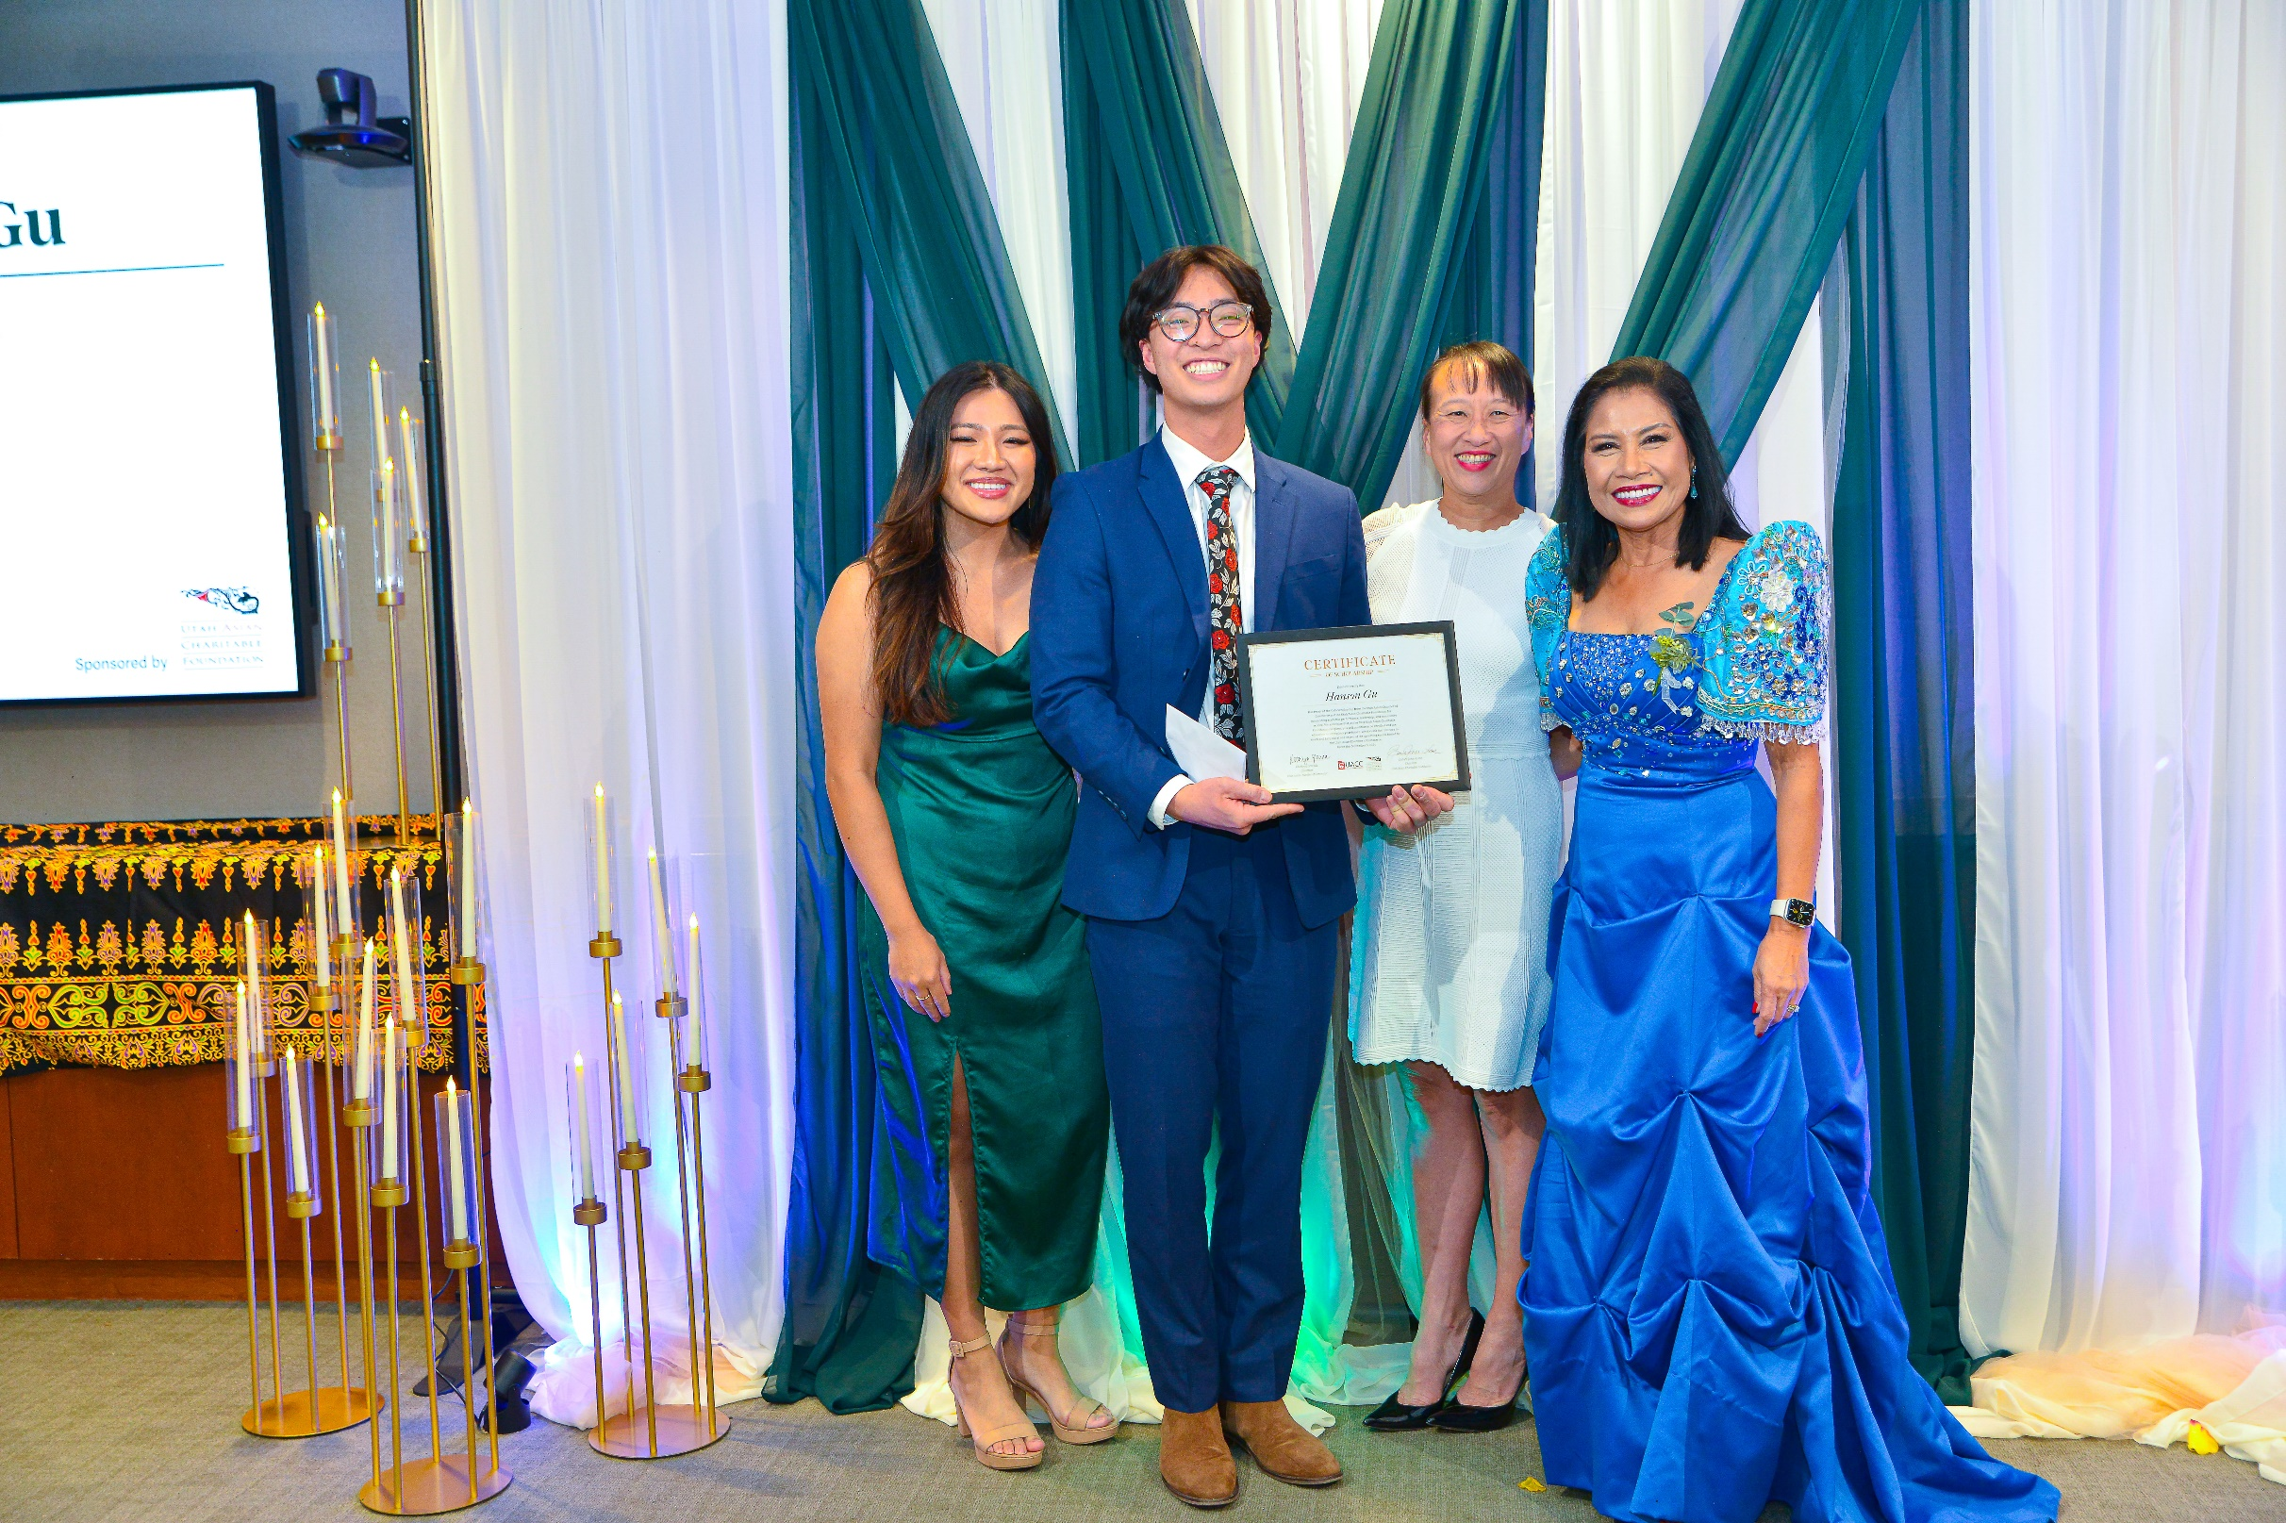
As part of the assembly, I want to advocate for the students and ensure the students in the David Eccles School of Business get the best possible experience with the help of RSOs.

Logan Mink
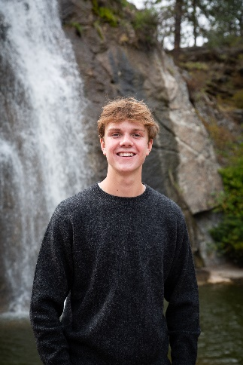

Samuel McCallam
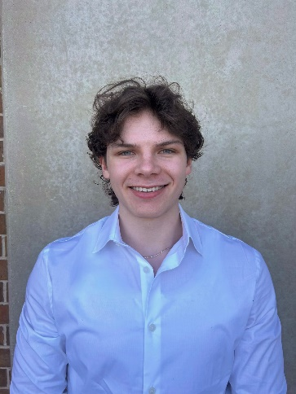

Steve Contos
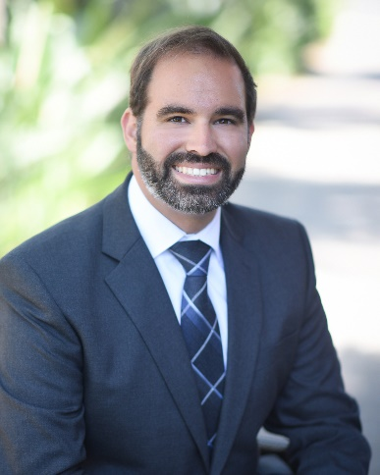
As a MBA student, I'm committed to amplifying all student voices, advocating for resources that enhance academic and professional growth, and ensuring fair allocation of student fees. Together, we can build a stronger community at The U.

Téa Driver
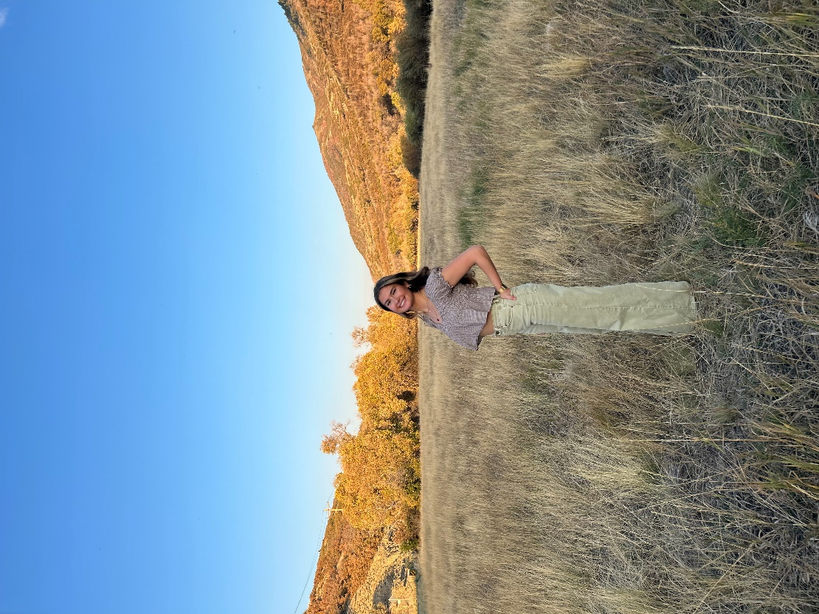

Jack Harrison
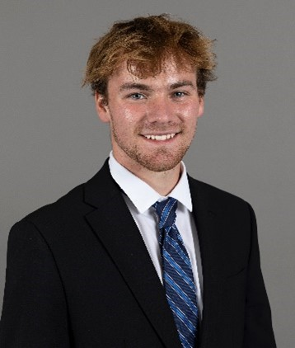

Weston Means
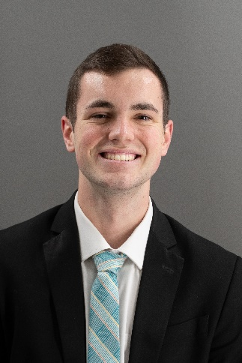
WESTON MEANS BUSINESS!!! Vote for me if you want to maximize the resources and usefulness of our beloved business clubs!

Sarie Lowry
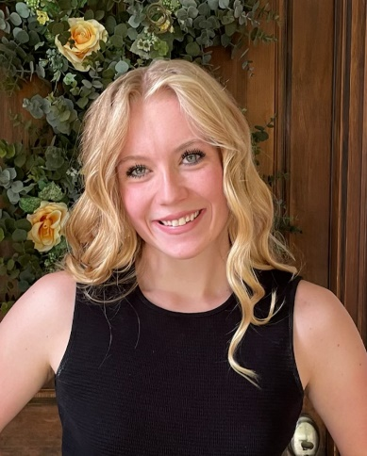
I believe in making student government more approachable, efficient, and impactful. Whether it’s improving campus resources, increasing student involvement, or ensuring our voices are heard in key decisions, I’m committed to making a difference!

Mya Oetinger
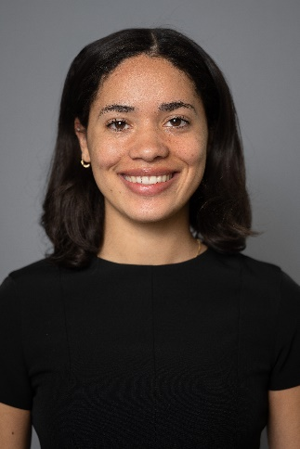

Tony Laciura
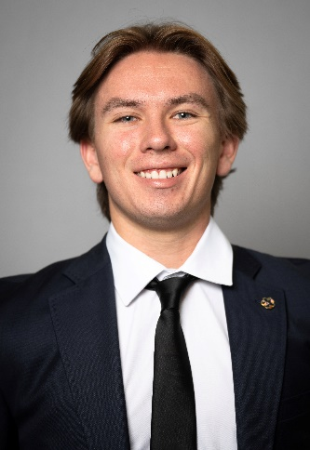
Dedicated to representing the College of Business, I will work to enhance student opportunities, strengthen career development resources, and foster a more connected business community. Your voice matters, let’s make a lasting impact together!

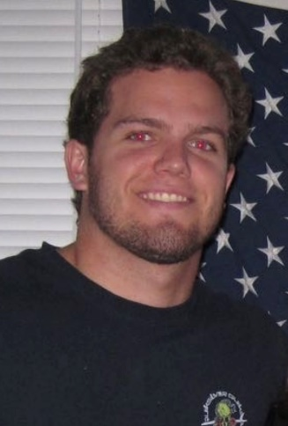
Trent Steiner

Landon Mokhtari
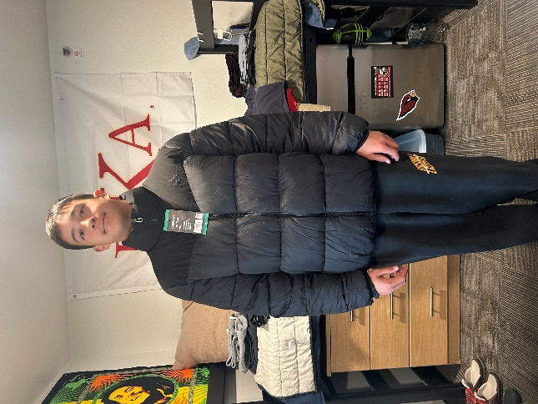

Ben Hosler
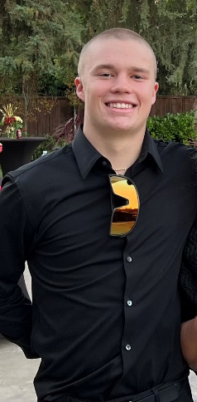

Cultural & Social Transformation
Sadie Werner
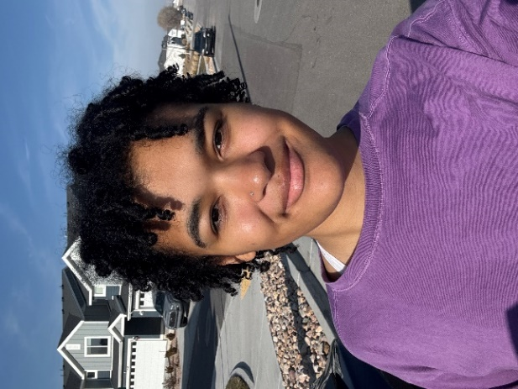
I am passionate about elevating voices often unheard. As a POC, I am passionate about being an advocate for change and bettering this University for students of all backgrounds. I have loved representing Transform for the past school year.

Dentistry
Saib Abdulnoor
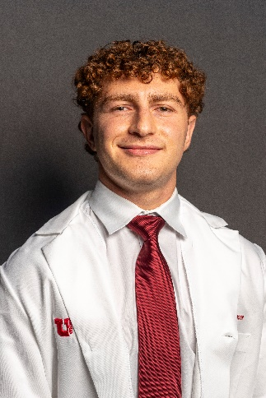
I am committed to representing the School of Dentistry with integrity, fairness, and dedication. As a passionate advocate for my peers, I will work to ensure our voices are heard, promote inclusivity, and strengthen our impact on the community.

Education
Blythe Wilde
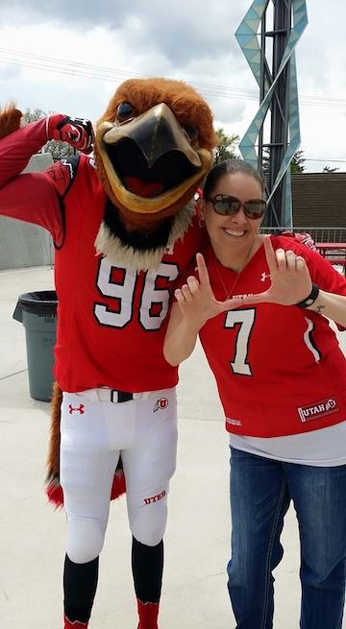

Engineering
Jose Hernandez
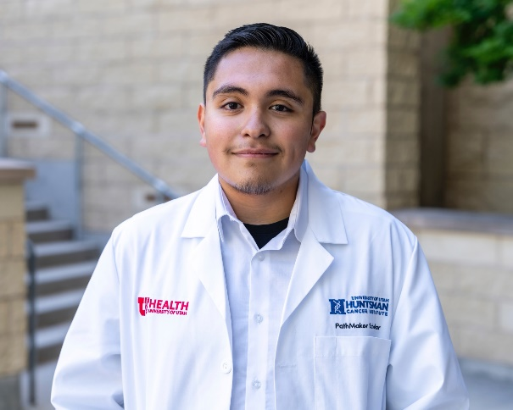
I am committed to advocating for engineering students. I will push for research stipends, better internship access, and increased funding for clubs. With your vote, we can build a stronger, more connected Engineering community!

Raksha Prasad
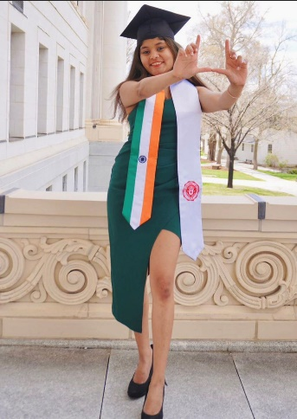
As an International EE 5+ student, TA, and campus leader, I understand student challenges. I’ll advocate for industry connections, inclusivity, and student support. Vote for me to represent "U", drive real changes by making "U" heard and empowered!

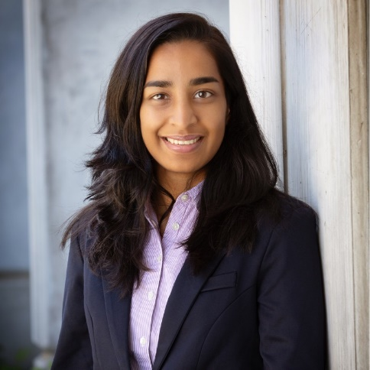
Nikita Singhi

Erik Bond
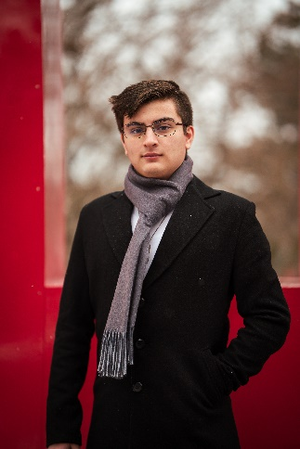
Erik Bond has 2 years of experience as an Assembly Representative for the College of Engineering. During his time he has used his role to advocate for increasing student outreach, sustainability initiatives, and holding ASUU officials accountable. @ebondasuu

Byron Stewart
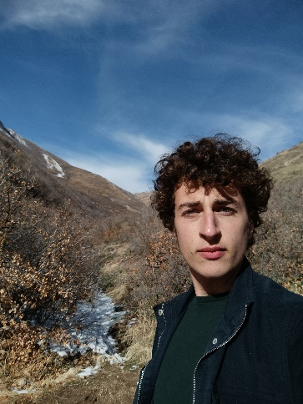
Engineering is my passion ;-)

Christina Dong
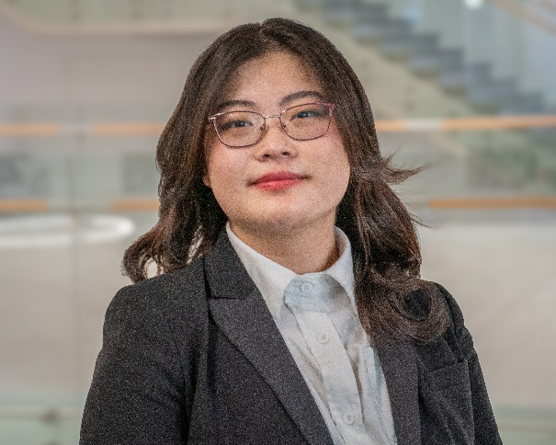


Haley Feuerher

Rayan Merchant
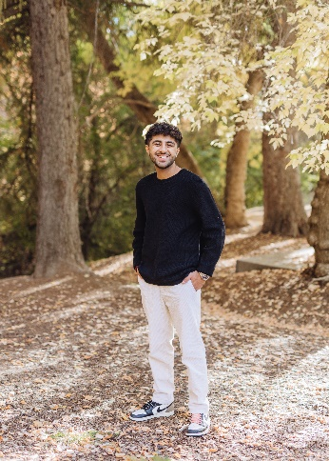

James Utton
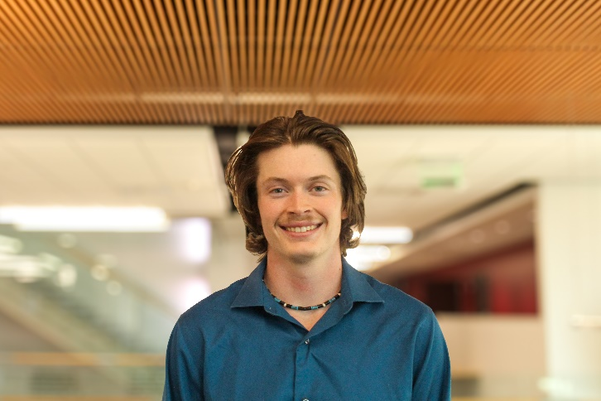
As a dedicated student leader, I strive to enhance student representation, promote transparency, and advocate for initiatives that improve campus life. I am committed to fostering an inclusive community where all voices are heard and valued.

Fine Arts
Juan Gomez
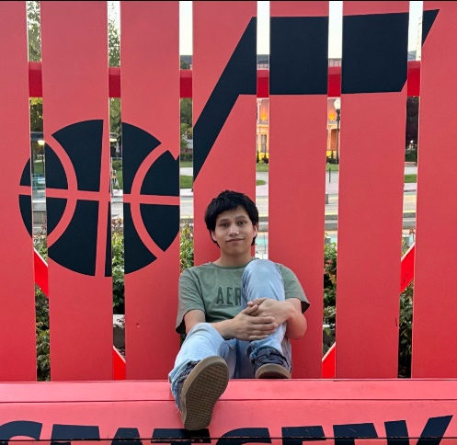
Creativity flourishes in a strong community. I’m dedicated to fostering collaboration, amplifying student voices, and ensuring every artist feels seen and supported. Let’s work together to make the College of Fine Arts a place where all can thrive!

Health
Kyra Chan
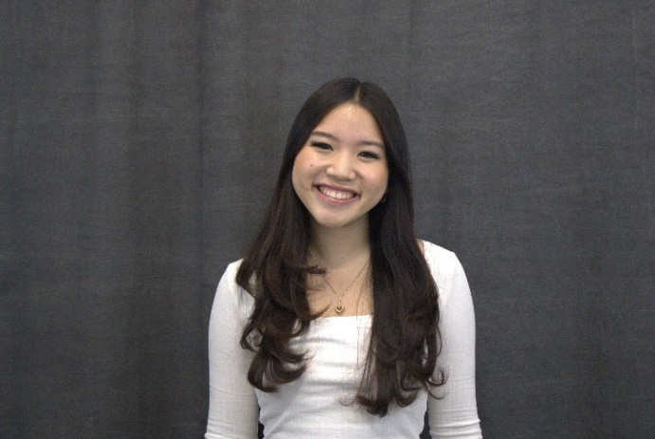
I aim to advocate for policies and initiatives to enhance academic experiences and support students’ overall well-being within the College of Health. I am committed to fostering a supportive environment that empowers YOU to thrive!

Humanities
William Miles
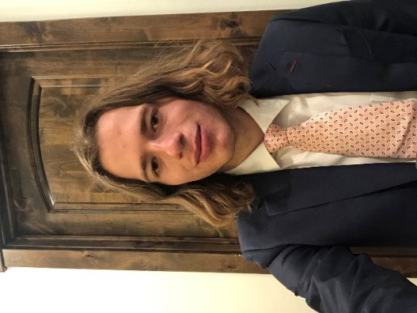

James VanLooy
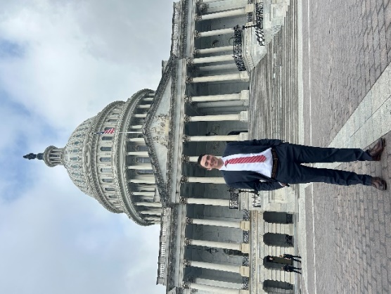
My main goals are to pass legislation requiring greater ASUU transparency, including mandatory updates sent to students, and to defend the humanities by working with colleges like ours and by showing the professional value of the humanities.

Reese Maranda Van Dyke

Humanities teaches people how to think. Given HB 192 cutting university funding, I hope to develop legislation like Representative Bond and Senator Johnson’s "Resolution for the Embedding of Humanities Ethics in AI-Related Engineering Majors."

Law
Andrew Scrimsher
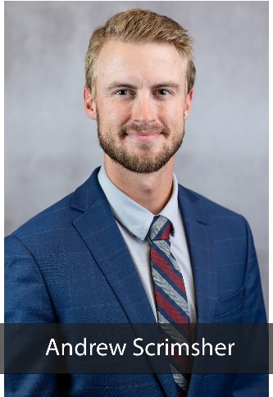
I hope to bring fresh ideas, analytical thinking, and positivity to the legislative assembly.

Medicine
Sarah Petelinsek

As an advocate and leader, I will work to enhance student well-being, expand professional development, and strengthen community engagement. I’ll champion inclusivity, mental health, and service opportunities to ensure we thrive as future physicians.

Freddy Espinoza
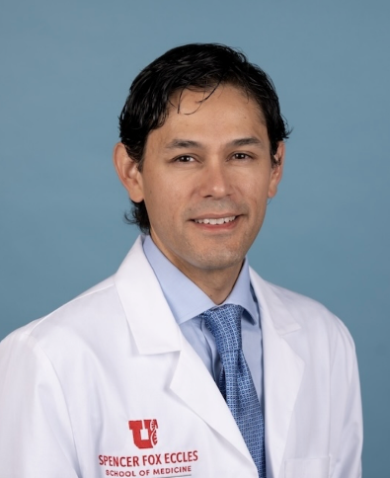
Since starting medical school, I’ve noticed the need for more cross-school (JD, PA, Nursing, Doctoral, MD) events and hope to encourage that funding in our student org allocations. I look forward to supporting policies that unite us as a university.

Nursing
Gabby Murillo
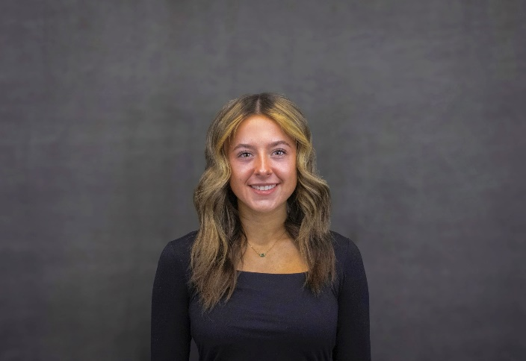

Naomi Brown
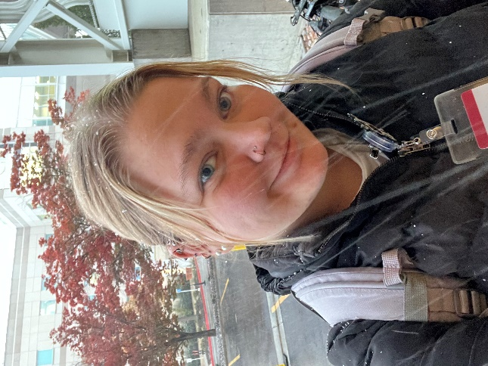

Pharmacy
Sarah King
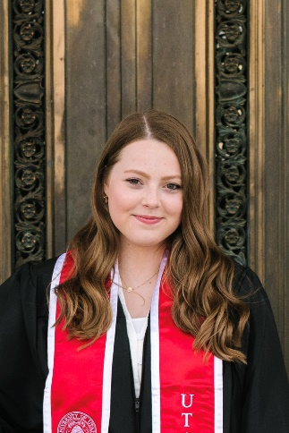
I am running for Legislative Assembly to improve communication
between the College of Pharmacy and ASUU, unite our student body
and advocate for pharmacy students utilizing my pharmacy,
volunteer, and leadership experience across campus.

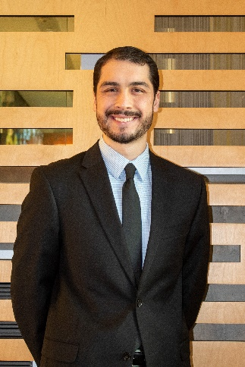
James Gustat
As your Representative, I will work to resolve issues that are impacting your success. I promise to listen to you, be your voice, and doing everything that I can to ensure your needs are met. You can count on me to get the job done.
Science
Merrin Maughan
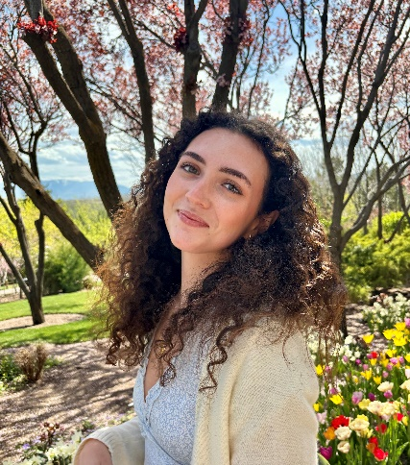
As a current Assembly Rep, I’ve worked to advocate for mental health resources & push for Honors College representation. I’m committed to advocating for student well-being & representation in ASUU - thank you for your consideration & support!

Ethan M. Hood
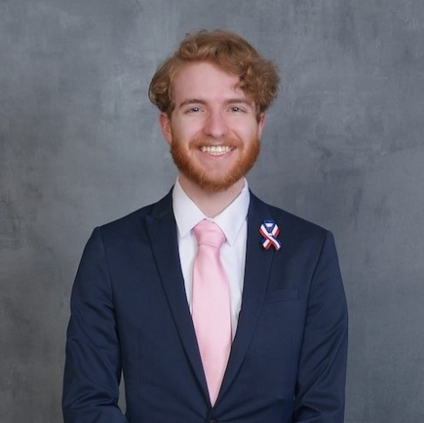

Dawson Wheeler
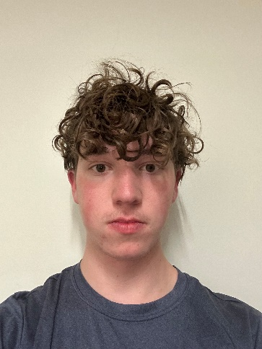

Navi Brar
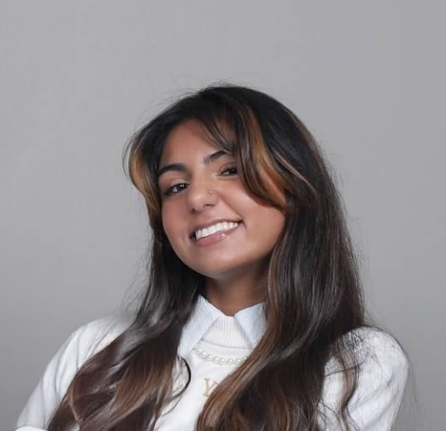
I’m Navi and I’m running to be your College of Science Assembly Representative! This upcoming year, I will advocate for more access to research opportunities, foster a closer community between students, and bring awareness to mental health resources!

Evelyn Newson
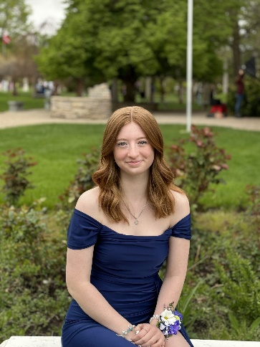
Hi! My mission is to ensure our budget is spent on more tutoring places/positions. It is important to have space for every major to find specific tutoring for each of their classes, and I hope to make this possible.

Social & Behavioral Sciences
Ethan Hepworth
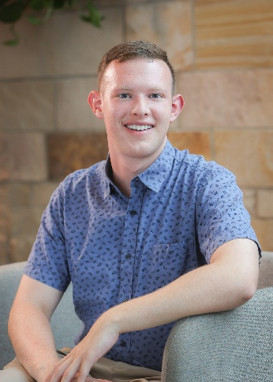
My name is Ethan Hepworth and I am running on a platform of affordable campus grocery options, increased public transportation, and advocacy for the arts

Raquel Juarez
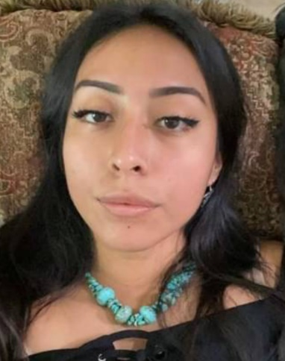
I chamption an inclusive environment that prioritizes clean energy, diversity, and equity. By advocating for sustainable practices and ensuring all voices are heard, I will work to create a space where every student feels supported and empowered.

Mason McCann
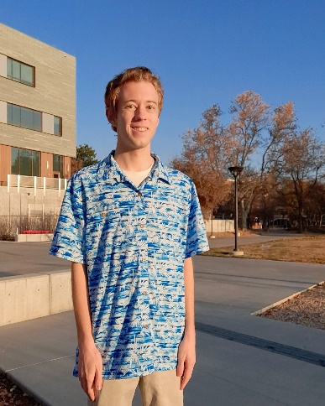
My main priority is finding a way to address the parking crisis by saving our parking lots. My second goal is to make the club funding process transparent. My final goal is to loudly use my voice as an ASUU rep to stand up for marginalized students.

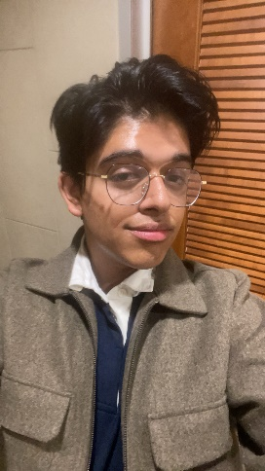
Shubham Pokharel
My mission is simple: fight forward for every student. This means I will advocate for you through 4 actions: Transparency & Awareness, Advocacy for RSOs organizations & Funding, Direct Communication with ASUU, and Improving Curriculum Accessibility.

Caleb Hague-Smith
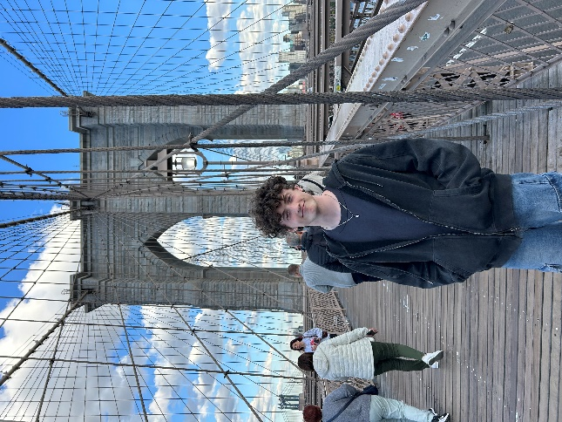

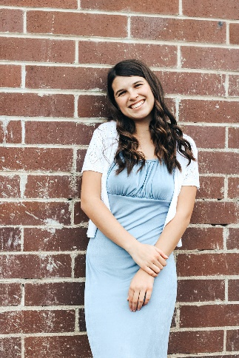
Riley Clark
I will advocate for increased funding for clubs that are connected to the social sciences. Campus RSOs can receive ASUU funding, but money is often limited and scarce. I support more money going SBS clubs to continue to increase involvement.

Julie Cerron
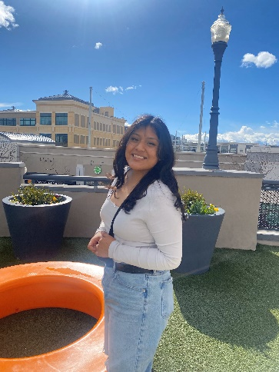
Julie is a Political Science and Economics freshman, involved in FYC at ASUU and serves as a Board Rep for the Latinx Student Union. She aims to enhance Commuter Resources, promote Equitable RSO Funding, and improve Accessibility in ASUU.

James Blackford
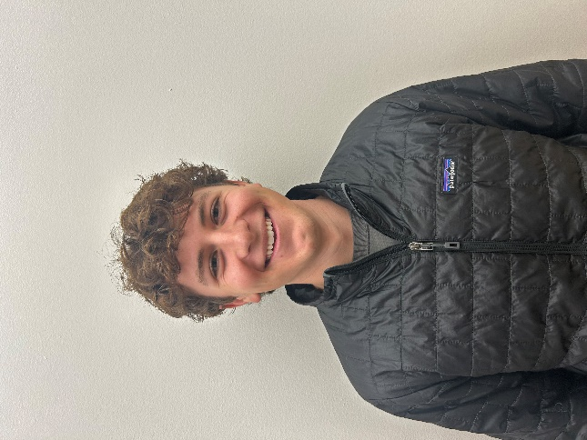
Hi, my name is James Blackford, and I'm a first-year political science major. I want to build on my current work by focusing on ASUU funding, increasing awareness of ASUU resources, and addressing long-term issues at the U.

Rayshon "Ray" Baker
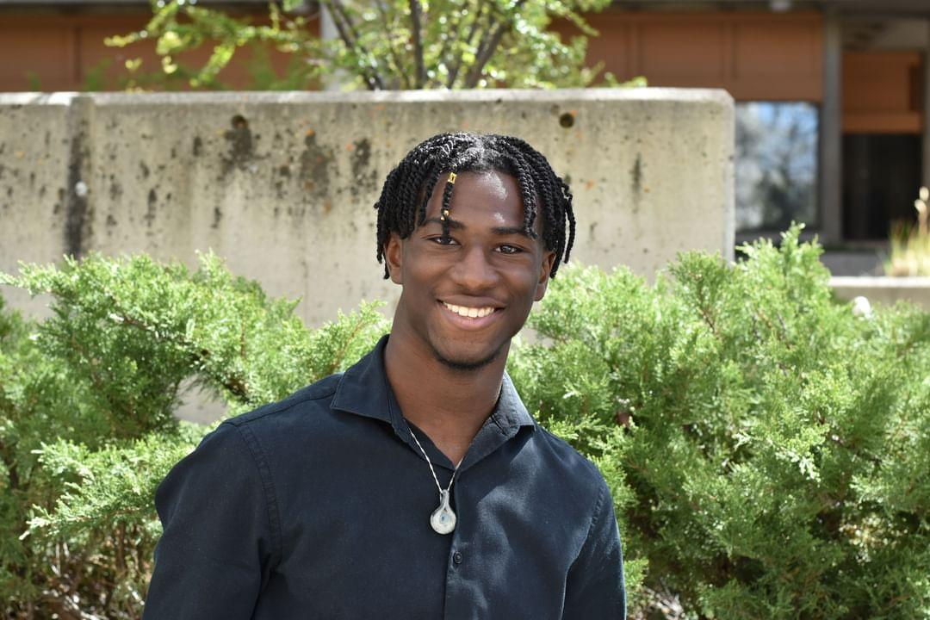
Transparency of ASUU functions and responsibilities, Voice for CSBS Students at the U, Promotion of RSOs on campus and Enhancing the Student Experience.

Mikayla Fairchild
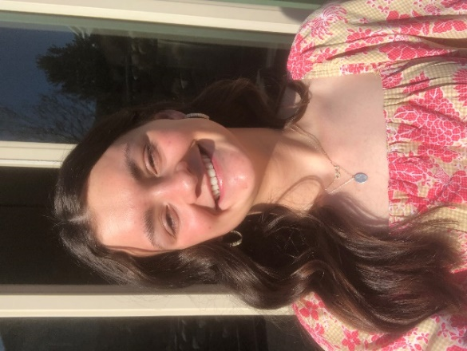

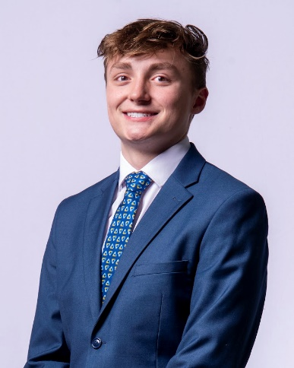
Jarom Guymon
I’ll fight for transparency in budget decisions, protect student resources, and push for better mental health support. With state funding changes ahead, we must ensure our education isn’t compromised. Let’s make the U a place where students thrive.

Social Work
There is no candidate for the Assembly of Social Work please contact ASSU if you or anyone you know is interested in this vacant position

Undergraduate Studies
Annie Knight

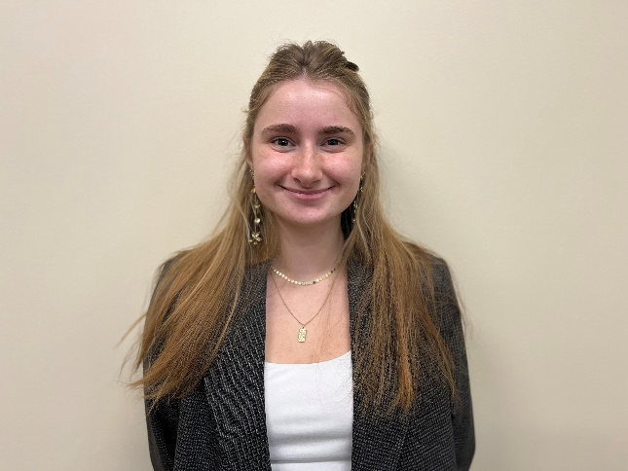
Senate Candidates
Architecture & Planning
Jack O’ Leary
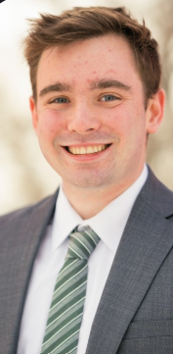
Vote O'Leary for Communication, Connection, and Change. If elected, I will be a strong advocate for you and will be able to leverage my many years of relationship-building and over five-plus years of ASUU experience to get the job done.

Elvis Valenzuela
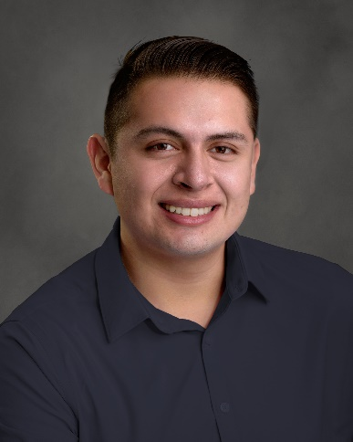
Creating communication between students and the University. I try my best to fulfill promises and commitments.

Business
Angela Aleman
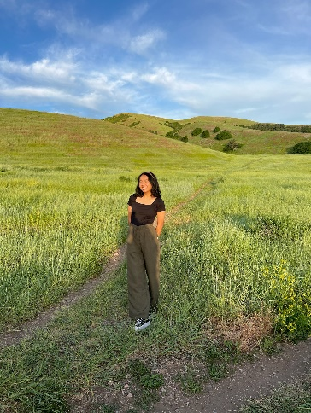

Tammy Phung
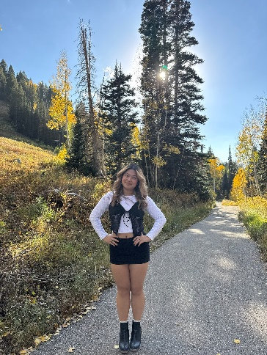

Khalid Moussa
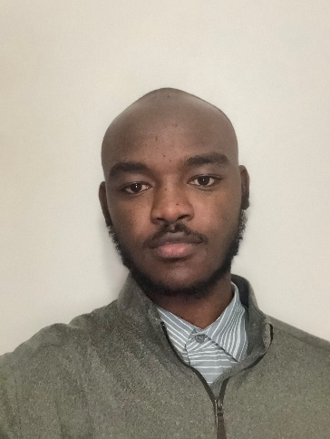
Hello, fellow students! My name is Khalid, and I’m excited to run for school senator to represent YOU.

RJ Spratling
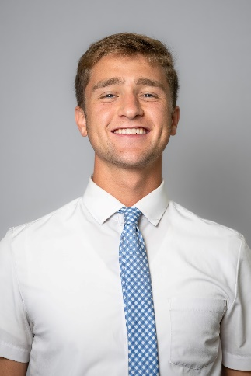
Exited to make the business school work for all students and drive our success now and into our future careers!

Noelle Maalouf
(No Photo Provided) Hi! My name is Noelle, I’m running to be your David Eccles Business School Senator. I pride myself in being open to all ideas, pushing for what the people want, and making our school a diverse and optimistic community. Vote Maalouf!

Sawyer Peterson
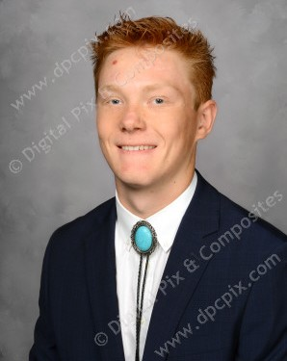
I'm excited to announce my candidacy for Senator of the School of Business. As a student who values innovation and growth, I'm committed to ensuring your voices are heard and your experiences at the School of Business are rewarding and empowering.

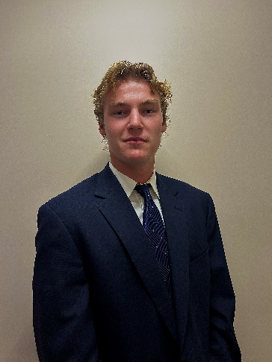
Bryce Perkins

Cultural & Social Transformation
Juniper Nilsson
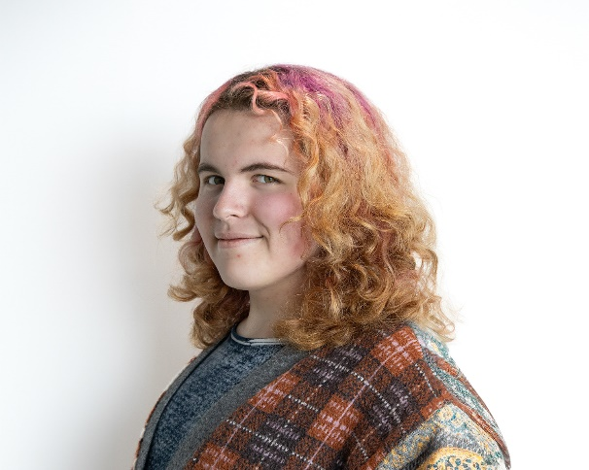
As a Gender Studies major and Disability Studies minor, I am excited to work with elected members of ASUU to improve the campus experience for all of our students in the areas of accessibility and community advocacy.

Dentistry
Eli Asay
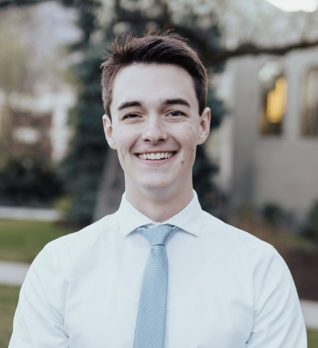
I am committed to serving my community and the College of Dentistry with integrity. With understanding and perseverance, I will work to create positive change. I promise to support those in need and contribute to progress.

Education
Ana Sanchez Benet
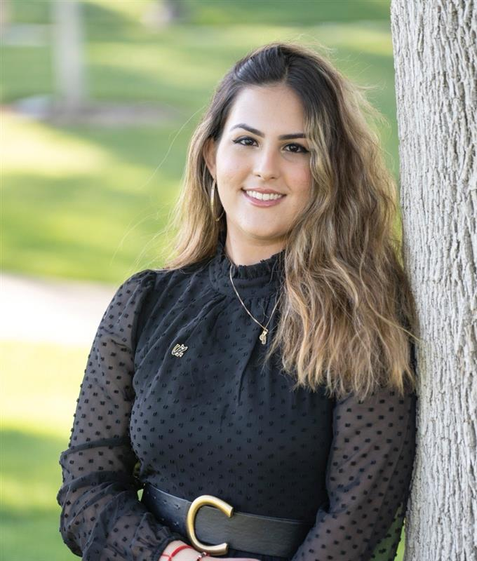
Hello! I'm Ana Sanchez Benet, running for senator for the Education department. As a committed graduate student, I'm focused on positively impacting our academic experience and ensuring every voice is heard.

Jesse Chavez
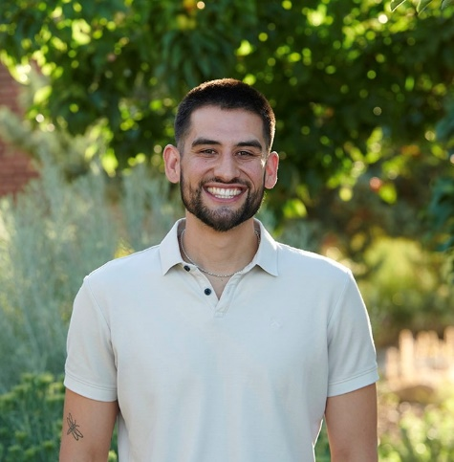
As an educator and CMHC graduate student, I am committed to advocating for students and inspiring change. My goal is to strengthen our community so every student feels valued and empowered. I’d be honored to serve as your representative.

Engineering
Jace Boyd
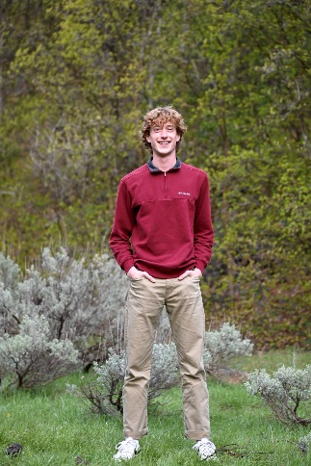
I'm currently a member of FYC in ASUU, and I’m running to represent you in the Senate. I want to boost the College of Engineering’s involvement in student government and empower your voice in bettering our campus.

Fine Arts
Alec Stevens
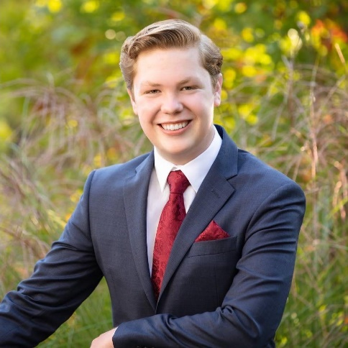
Hello, I’m Alec Stevens, a Bachelor of Music student here at the University of Utah. I’m running for College of Fine Arts Senate Chair in ASUU to advocate for students, ensure proper funding allocation, and drive meaningful legislative change.

Karley Swallow
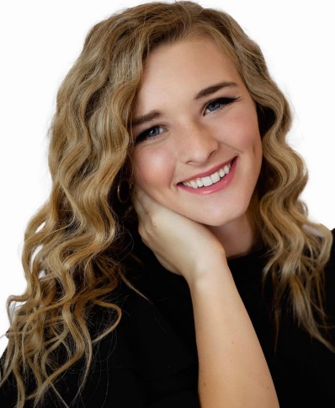

Health
Pete Benda

Running for ASUU Senate, I stand for inclusivity, equity, and student wellness. I pledge to boost funding and improve campus accessibility so every student’s voice is heard. Let’s build a stronger U together!

Mayette Pahulu
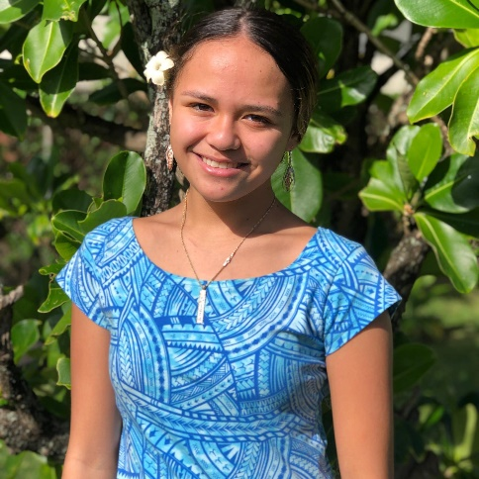
I’m Mayette Pahulu, and I’m committed to prioritizing student wellbeing, equity, and belonging in the College of Health. I will work to ensure all students have access to resources, feel supported, and thrive in a welcoming campus community.

Humanities
Anna Locke
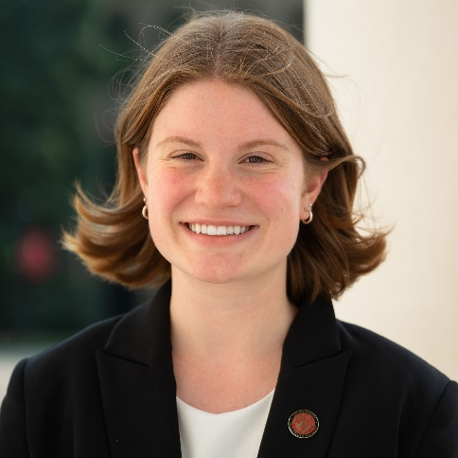

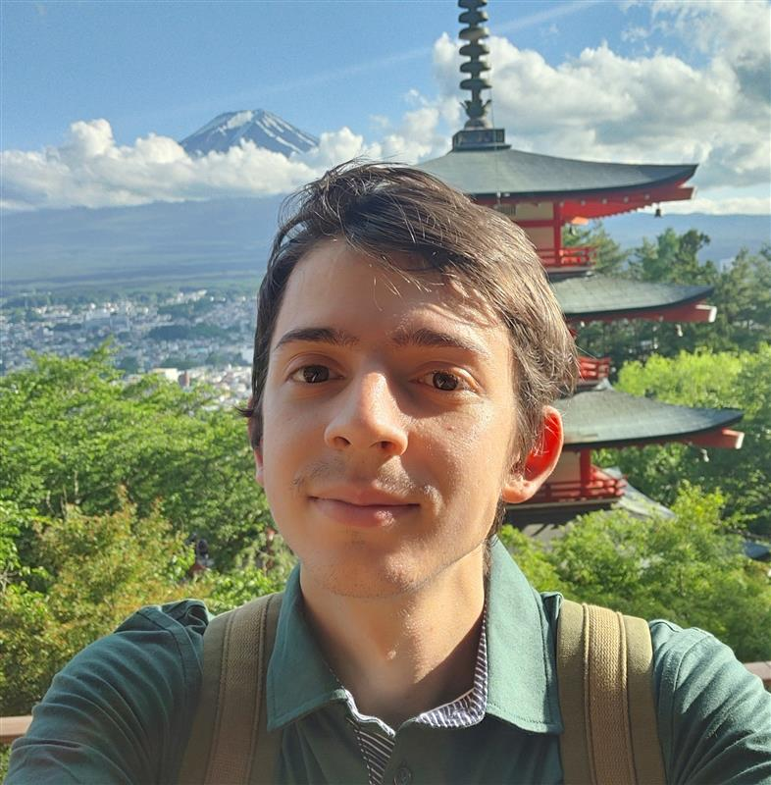
Christopher Francesco Viapiano

Naomi Rowley
(No Photo Provided)
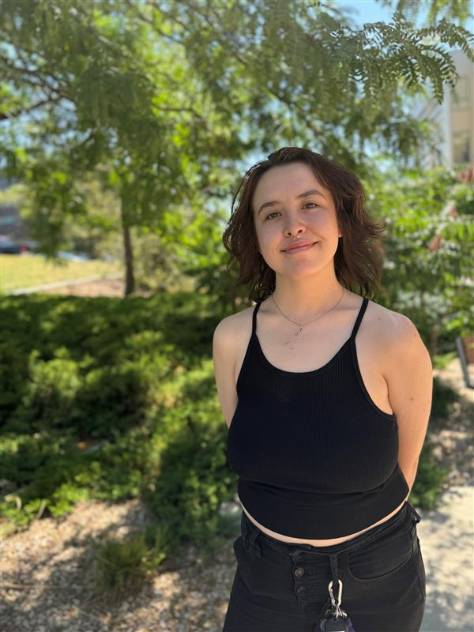
Pamalatera Fenn

Law
Brooke Davies
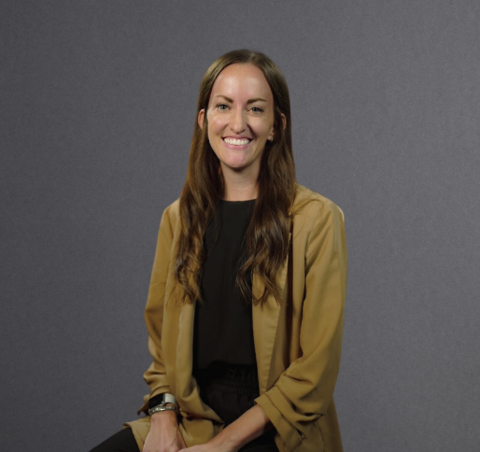

Medicine
Scott King
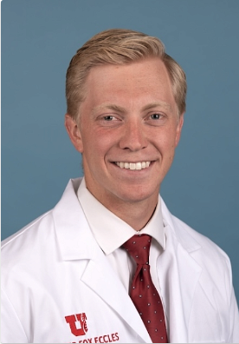

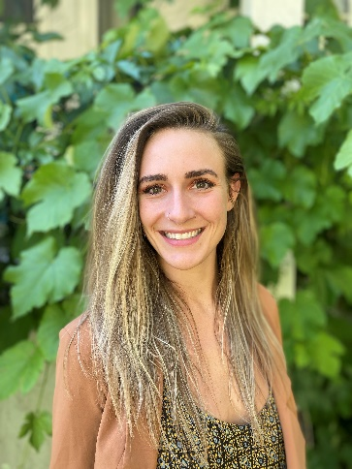
Hailey Lawrence

Nursing
Garrett Schwanke
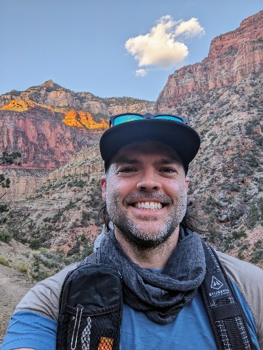
I’m a 2nd-year psychiatric DNP student and moral injury researcher. I founded Utah Health Workers United (uhwu.org) to advocate for HCWs. I want to advocate for you in the Legislative Senate! My priorities are your student experience and well-being.

Ayla Chase


Brooke Fernandez

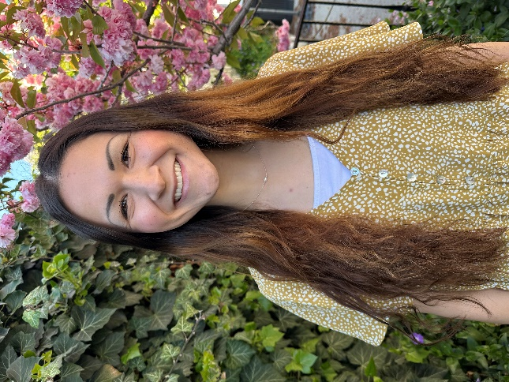
I am committed to advocating for nursing students by promoting collaboration, clear communication, and a supportive learning environment. I will ensure our voices are heard and education strengthened to prepare us for success in patient care.
Pharmacy
Kennon Buss
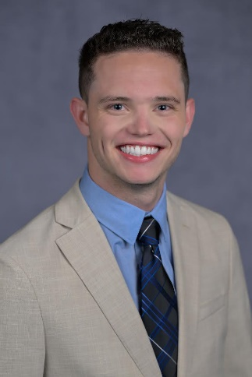

Science
Sofia Perez
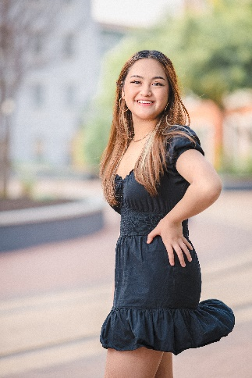
Hey guys! My name is Sofia Perez, and I am re-running to be your College of Science Senator once again! I want to advocate for your voice and bring new, innovative ideas to make the science community an inclusive, welcoming place for all students!

Riley Perkins
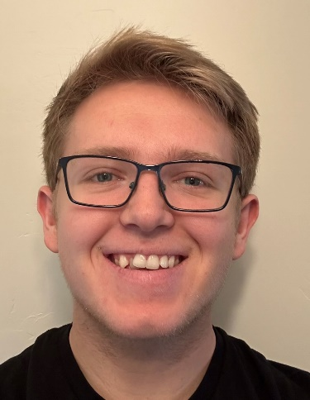
My goal as your senator is to find all valuable resources on campus, make them easier to find online and create legislation that brings these resources to you! No more endless searching for needed resources that will make your time on campus great!

Social & Behavioral Sciences
Joon Sang Ryu
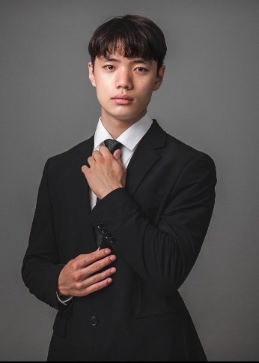

Demetri Engel
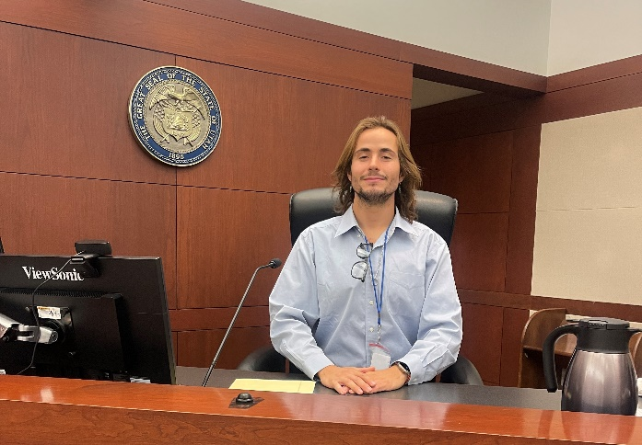

Rorie Stewart
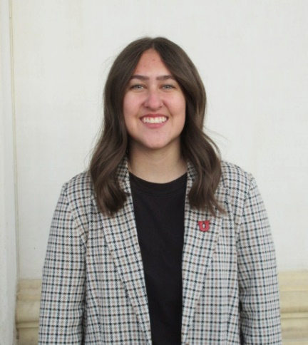
I will prioritize student well-being, safety, and academics, improve ASUU procedures, and ensure student needs are addressed. I'll strengthen ASUU-student connections, and promote civic engagement and involvement on campus.

Maddy Hadwick
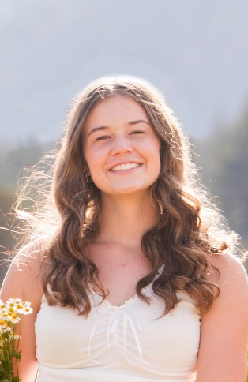

Shaiban Khan
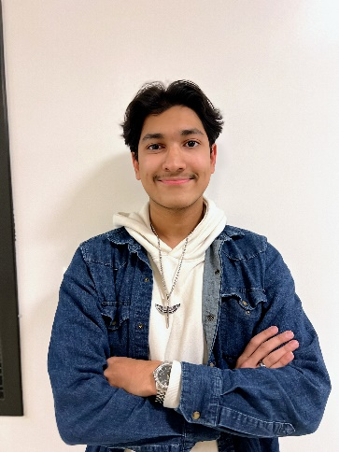
Want a PLAN!? Vote SHAIBAN I'll improve RSO Funding, Advising & Waitlist, RSG for CSBS, & Transparency in ASUU With 6+ years of leadership and State Govt. connections, I seek YOUR trust to represent YOU!! Vote SHAIBAN: He does what others CANT

Jasmine Malhi
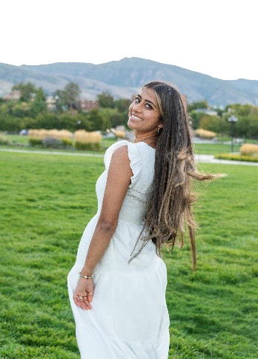

Kennedy Pina
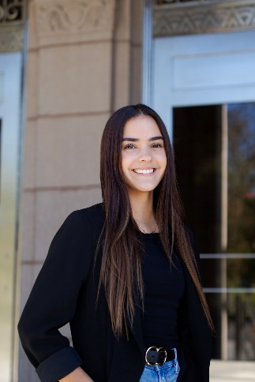

Social Work
Berkley Wiseman

My mission is to foster growth for student government in Social Work & allocate more funding to ensure student success. To achieve that, I will create a registered student government (RSG), which will work to advocate for the College of Social Work.

Undergraduate Studies
There is no candidate for the Senator of Undergraduate Studies please contact ASSU if you or anyone you know is interested in this vacant position



Scan Here to Vote in 2025 ASUU General Election

